Linda Hitt – Biography

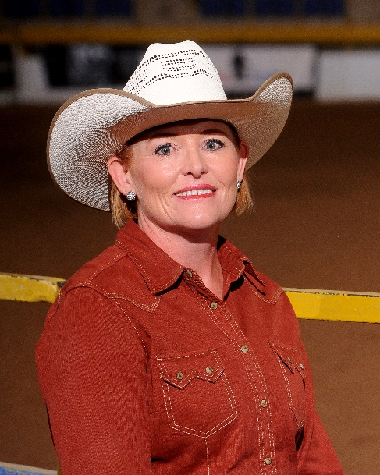
I have been a professional horse trainer for the past 23 years. I own and operate Gambel Oaks Equestrian Center in Elizabeth, Colorado with husband Jim Hitt. My first experience with horses began early in life with horses being the center of my life. I have been fortunate to experience and participate in many disciplines, everything from roping to endurance riding, with my primary passion being for reining and cow horse. In 2014, I sustained a life changing injury, putting me on the sidelines for much longer than I could have anticipated. I have learned a lot sitting on the sidelines. I hope to bring my many life lessons to those I coach.
As a professional, I have learned my main goal is help people learn to appreciate and communicate with their horse. Often, we get caught up in the end results and I have learned- sometimes the hard way- having, riding and showing horses is about the journey, not the destination. I have always said, “the horses teach me more than I teach them”.
I currently hold judge’s cards for National Reining Horse Association, National Reined Cow Horse Association, National Versatility Ranch Horse Association, Ranch Horse Association of America and AQHA Specialty - Reining, Ranch Riding and Versatility Ranch Horse. I find judging to be a privilege and with every show, I learn something new.

